Aim: Execute the following Linux commands: touch, echo, clear, ls, Dir, Mkdir, Cat, Rmdir, Rm, Cp, Mv, Find, Head, Tail, Tar, Gzip, Bzip2, Alias, Sed, wc, sort.

# Learning Outcome: Able to work Linux environment by using Linux commands.

Duration: 8 Hour.

List of Hardware/Software requirements:

1. Computer Desktop/Laptop
2. Linux Operating System

# Code/Program/Procedure (with comment):

* ls

## ls

ls command shows the all files and folder.

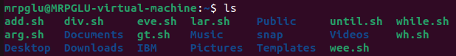

* mkdir

## mkdir p1

list the file and folder in columns.

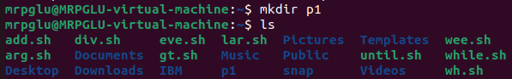

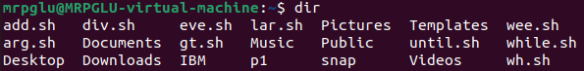

* rmdir

## rmdir p1

create a folder or a directory.

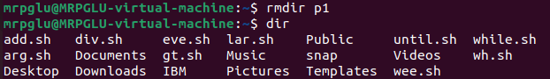

* cat

## cat> p1.txt

create a file with any content.

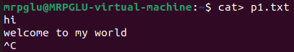

## Cat p1.txt

display the file contents.



* rm

## rm p1.txt

delete files and directories.

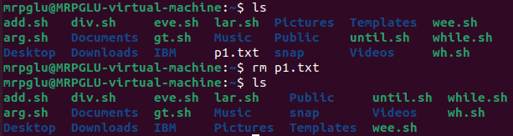

* touch

## touch

create a file without any content.

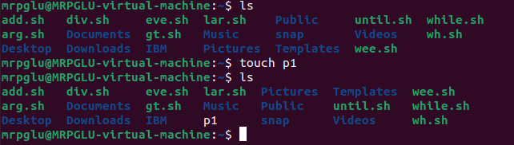

* echo

## echo what are you doing.



* cp

## cp p1.txt p2.txt

copy file contents to another file.

here you can take two txt file p1 and p2. here p1 have a txt data as show below image and another p2 don’t have any txt data.

When you run cp p1.txt p2.txt cmd. you can see p1.txt file content copy to p2.txt.

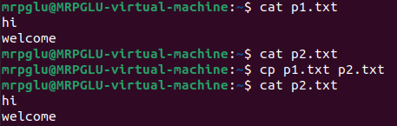

* mv

## mv p1.txt p2.txt

move file through the command line.

here you can take two txt file p1 and p2. here p1 have a txt data as show below image and another p2 don’t have any txt data.

When you run mv p1.txt p2.txt cmd. you can see p1.txt remove and p1.txt all content move to p2.txt see below image.

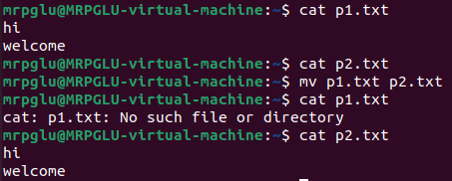

* find

## find p2.txt

find file and directories and perform subsequent operating on them.

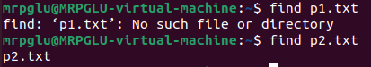

* head

## head p3.txt

head show the first top 10 content lines.

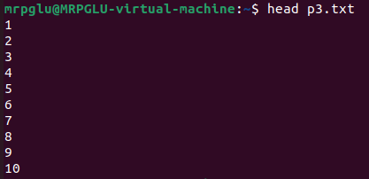

* tail

## tail p3.txt

tail show the last 10 lines.

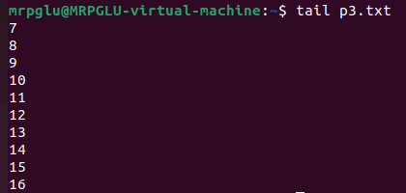

* sed

## sed ‘s/linux/unix/’ demo.txt

sed command use to replace (change word) a word.

Output:

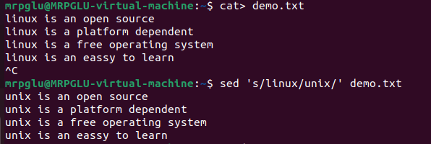

* wc

## wc demo.txt

wc use to count the no. of letter/word with line.

Output:



* sort

## sort demo1.txt

sort use to arrange the records in a particular order (A-Z).

Output:

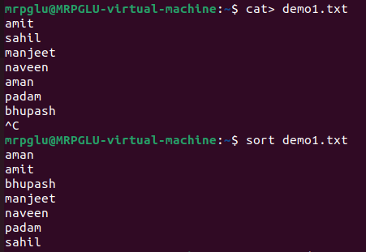

Sort -r demo1.txt

Sort -r is use to reverse the record in a particular order (Z-A).

Output:

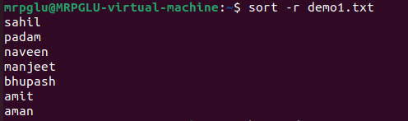

* bzip2

## bzip2 demo1.txt

compress file.

Output:

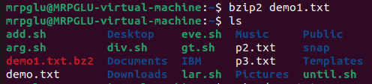

Bzip2 -d demo1.txt.bz2

Decompress file

Output:

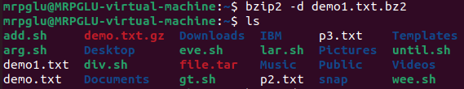

* gzip

## gzip demo.txt

compresses file.

Output:

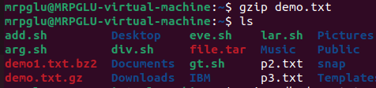

gzip -d demo.txt

decompress file.

Output:

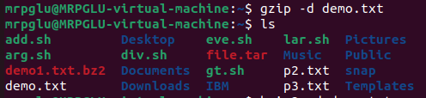

* tar

## tar cvf file.tar *.txt

work with tarballs (or files compressed in a tarball archive) in the linux command line.

Output:

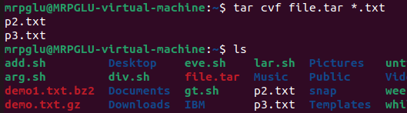

* alias

## alias c=’clear’

instructs the shell to replace one string with another string while executing the commands.

Output:





* clear

## clear

keep screen tidy from filled up commands and output of those commands.

Output:



